The Judicial Branch: an outline for review
(make sure you’ve watched the Structure of the Federal Courts video by Eugene Kim: https://www.youtube.com/watch?v=i_mbk0YhLa0 )

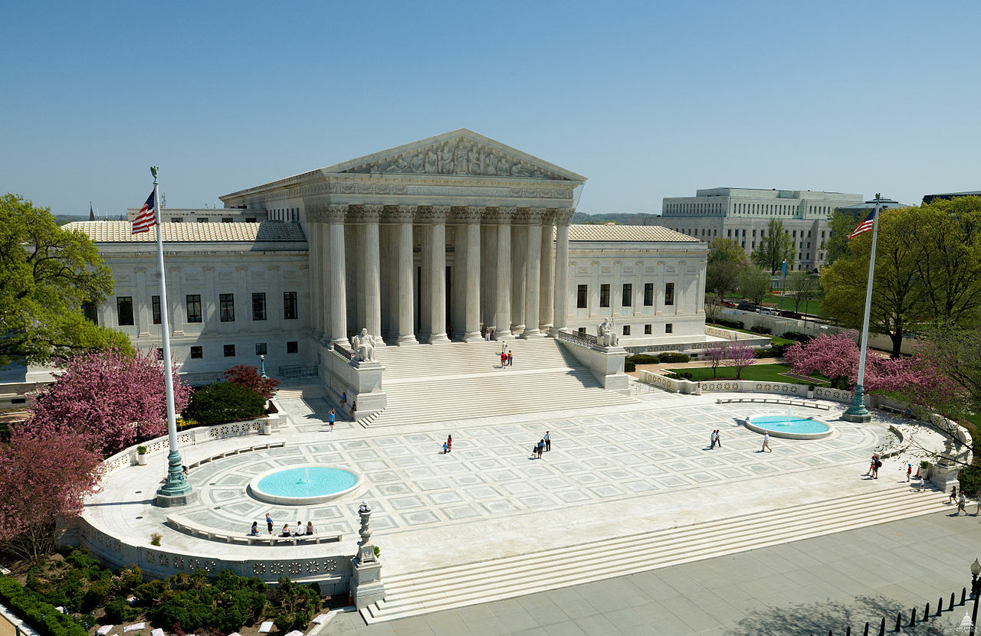

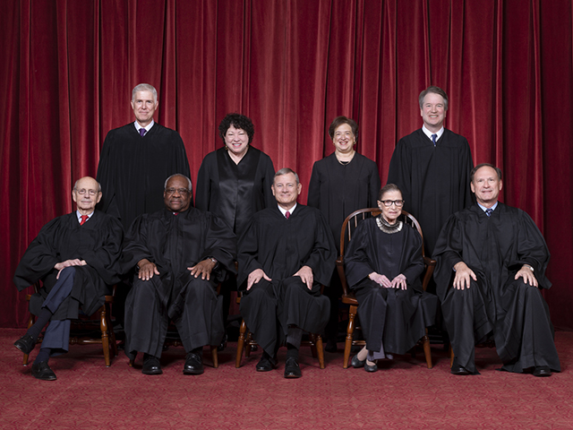

The Current Court
Front row, left to right: Associate Justice Stephen G. Breyer, Associate Justice Clarence Thomas, Chief Justice John G. Roberts, Jr., Associate Justice Ruth Bader Ginsburg, Associate Justice Samuel A. Alito. Back row: Associate Justice Neil M. Gorsuch, Associate Justice Sonia Sotomayor, Associate Justice Elena Kagan, Associate Justice Brett M. Kavanaugh.

Go to the SCOTUS Homepage to HERE audio recordings of arguments, as well as other cool stuff
https://www.supremecourt.gov/

Objectives:

- History
- SCOTUS created in Article III of the U.S. Constitution
- There are 9 Justices (1 Chief Justice and 8 Associate Justices that are appointed/nominated by the President and approved/confirmed by the Senate). So the aforementioned are two checks on the Judicial Branch, one from the executive branch and one from the legislative branch respectively.

- SCOTUS Justices serve a life tenure “for good behavior”, but they may be impeached/convicted by Congress and removed from office. And here is yet another check on the Judicial Branch, by the Legislative Branch.

- What are the ramifications for public policy as result of life tenure? ALSO, how might life tenure effect the legitimacy of the Court?

- Judiciary Acts of 1789 and 1891 created the Federal District Courts and the Circuit Courts of Appeal respectively (the point here is that Congress creates new federal courts, and can change some of the jurisdictions of federal courts, even the number of judges on the federal courts, including justices on the SCOTUS)…uhh, yet another check.

- Jurisdiction (the area over which a court has authority)
- Original jurisdiction: the court in which a case is first “heard”.
- Appellate jurisdiction: the power of a higher court to review decisions and change outcomes of decisions of a lower court
- SCOTUS has original jurisdiction in the following types of cases:
-cases involving a foreign diplomat
-a case between the United States and a state
-cases between two or more states
-a case between one state and the citizens of another state
-a case between a state and a foreign country

- Functions of the SCOTUS:
- Interpret the law
- Conduct “Judicial Review” (Marbury v Madison, 1803) of federal laws, state laws, executive orders, and the regulations and rules made by the bureaucratic agencies in the executive branch. We’ll examine this case in detail at the end of this lesson.
- Make public policy and create precedent (i.e. stare decisis…decisions or rulings that are made to be followed in the future until the precedent is “overturned” by a future SCOTUS): e.g. Plessey v. Ferguson (1896) being overturned by Brown v. Board (1954)

- Checks (restrictions) on SCOTUS and the other federal courts:
- The president has appointment power over judges
- The Senate has confirmation/approval power over president’s judicial nominees with its constitutional power of “advise and consent”.
- Congress can pass a law that abrogates specific aspects of a law SCOTUS has deemed constitutional
- Congress and the states can amend the Constitution
- The president and the states can evade or ignore Supreme Court decisions

- 3 Levels of Federal Courts and their Jurisdictions (not so important for you to know this except as a means to understanding the route a case may take to get to SCOTUS):
- SCOTUS is the country’s “court of last resort or final appeal”, and thus, is an appellate court. It also has original jurisdiction over cases involving states and foreign diplomats. There are no trials in SCOTUS. SCOTUS hears cases on appeal from federal circuit courts and State Supreme Courts (state Supreme Court cases go directly to SCOTUS on appeal, assuming SCOTUS chooses to take them).
- Federal Circuit Courts of Appeal (13 of them)have appellate jurisdiction; they hear appeals from federal district courts
- Federal District Courts (94 of them): these are trial courts with juries (original jurisdiction only) that hear cases involving the breaking of federal law (both civil and criminal). There is a trial. There is a jury. The accused is found guilty or not guilty.

- When will SCOTUS take a case on appeal? (IMPORTANT STUFF HERE!!)
- First a case must be “justiciable” (capable of being decided by legal principles or by a court of justice) and have “standing to sue” (i.e. the person bringing the case to SCOTUS must show that s/he has incurred hurt/damage or most probably might).
- SCOTUS will only take a case if it involves a constitutional issue, an important federal question (e.g. cases on affirmative action, abortion, healthcare policy, physician-assisted suicide, etc.), or if there is a “circuit split” (i.e. 2 or more different federal circuit courts make conflicting rulings; e.g. Obergefell v Hodges was the gay marriage case SCOTUS took because different federal circuit courts had conflicting rulings on the constitutionality of gay marriage).

- What is the process for SCOTUS actually taking a case (only takes 1% of cases petitioned to the Court…approximately 80 out of 8000 annually). IMPORTANT STUFF HERE!!!

- First, the plaintiff petitions the Court for a “writ of certiorari” (i.e. the order from a higher court to a lower court to send “up” all the documents in a case so the higher court can review the lower court’s decision).
- The “rule of four” must occur (i.e. at least four of the 9 Justices must agree to take the case”). If this happens, then SCOTUS will issue the “writ of certiorari” to the lower court. FYI: The rule of four is a Supreme Court of the United States practice that permits four of the nine justices to grant a writ of certiorari. This is done specifically to prevent a majority of the Court from controlling the Court's docket (This is one reason a federal republic is good…the minority has a shot at equity)

- Though not mandatory, SCOTUS will either request or take unsolicited “amicus curiae briefs” (literally meaning “friend of the court”; defined as is someone who is not a party to a case (a litigant) and offers information that bears on the case, but who has not been solicited by any of the parties to assist a court.

- Three things SCOTUS may do after hearing a case (item 3 isn’t stressed by A.P., but I included it for you own edification):
- Affirm: the lower court ruling is “upheld” or “stands”; i.e. SCOTUS agrees with the lower court’s ruling. THINK “stare decisis” (i.e. let the precedent of the lower court stand).
- Reverse: the lower court’s ruling is “reversed” or “overturned”
- Remand: SCOTUS sends the case back to the lower court for review; remand is an action taken by an appellate court in which it sends back a case to the trial court or lower appellate court for further action. For example, if the trial judge committed a procedural error, failed to admit evidence or witnesses that the appellate court ruled should have been admitted, or ruled improperly on a litigant's motion, the appellate court may send the case back to the lower court for retrial or other action.
- Constitutional philosophies (IMPORTANT STUFF!!!):
- “originalism” vs. “the constitution as a living document”: “originalism” is a judicial philosophy that says the U.S. Constitution should be interpreted according to the original intent/meanings of the framers (a conservative view), while “the constitution as a living document” is a judicial philosophy that says the U.S. Constitution meaning is dynamic and changes over time according to how society/culture changes because of contemporary needs (a liberal view).
- “judicial restraint” vs. “judicial activism”: with judicial restraint, judges adhere more closely to previous court’s precedents (i.e. stare decisis) and play minimal policy-making roles, while with judicial activism” judges are less deferential to precedent and make bold policy decisions/changes that set new precedent (i.e. don’t pay as much attention to stare decisis). Political discussion about the Supreme Court’s power is illustrated by the ongoing debate over judicial activism versus judicial restraint.

- Legitimacy (i.e. is the court because of its rulings a valid institution): Precedents and stare decisis play an important role in judicial decision making.
Ideological changes in the composition of the Supreme Court due to presidential appointments have led to the Court’s establishing new or rejecting existing precedents.
Since the justices have life tenure, these precedents are public policy that can last for decades. So if a court is more “liberal” or more “conservative” in its most of its decisions, are citizens’ going to think that the court and its rulings are legitimate?

- Federalist Papers:
Summation in modern language: Federalist No. 78 discusses the power of judicial review. It argues that the federal courts have the duty to determine whether acts of Congress are constitutional and to follow the Constitution when there is inconsistency. Hamilton viewed this as a protection against abuse of power by Congress.

Federalist 78 by Alexander Hamilton Excerpts:
“WE PROCEED now to an examination of the judiciary department of the proposed government.
According to the Constitution, all judges who may be appointed by the United States are to hold their offices DURING GOOD BEHAVIOR; The standard of good behavior for the continuance in office of the judicial magistracy, is certainly one of the most valuable of the modern improvements in the practice of government. And it is the best expedient which can be devised in any government, to secure a steady, upright, and impartial administration of the laws.
The judiciary is in continual jeopardy of being overpowered, awed, or influenced by its co-ordinate branches; and that as nothing can contribute so much to its firmness and independence as permanency in office, this quality may therefore be justly regarded as an indispensable ingredient in its constitution, and, in a great measure, as the citadel of the public justice and the public security.

The complete independence of the courts of justice is peculiarly essential in a limited Constitution. [One duty of the judiciary] must be to declare all acts contrary to the manifest tenor of the Constitution void. Without this, all the reservations of particular rights or privileges would amount to nothing.
Some perplexity respecting the rights of the courts to pronounce legislative acts void, because contrary to the Constitution, has arisen from an imagination that the doctrine would imply a superiority of the judiciary to the legislative power. It is urged that the authority which can declare the acts of another void, must necessarily be superior to the one whose acts may be declared void. As this doctrine is of great importance in all the American constitutions, a brief discussion of the ground on which it rests cannot be unacceptable. [However], No legislative act contrary to the Constitution, can be valid. To deny this, would be to affirm, that the deputy is greater than his principal; that the servant is above his master; that the representatives of the people are superior to the people themselves; that men acting by virtue of powers, may do not only what their powers do not authorize, but what they forbid.

Nor does this conclusion by any means suppose a superiority of the judicial to the legislative power. It only supposes that the power of the people is superior to both; and that where the will of the legislature, declared in its statutes, stands in opposition to that of the people, declared in the Constitution, the judges ought to be governed by the latter rather than the former. They ought to regulate their decisions by the fundamental laws, rather than by those which are not fundamental.
If, then, the courts of justice are to be considered as the bulwarks of a limited Constitution against legislative encroachments, this consideration will afford a strong argument for the permanent tenure of judicial offices, since nothing will contribute so much as this to that independent spirit in the judges.

More Summation in Modern language:
The heart of this essay covers the case for the duration of judges in office. Hamilton points out that their lifetime appointments are guaranteed only “during good behavior.” He calls the insistence on this standard “one of the most valuable of the modern improvements in the practice of government.” To insure that judges maintain this standard, resisting encroachments from the legislature (to which presumably they would be vulnerable by means of bribes or threats), the Constitution gives them “permanent tenure.”
Hamilton then makes the famous claim that the judiciary “will always be the least dangerous to the political rights of the Constitution. . . . It may truly be said to have neither FORCE nor WILL but merely judgment.” As “the weakest of the three departments of power,” it needs fortification (i.e as Brooks says: lifetime tenure so the court isn’t swayed by trying to appeal to voters if the judges were put on the court through election and reelection by the people)
It is the “duty” of the courts “to declare all acts contrary to the manifest tenor of the constitution void.” Without an independent judiciary to fulfill this task, any rights reserved to the people by the Constitution “would amount to nothing,” since the legislature cannot be relied upon to police itself. This arrangement does not render the judiciary the supreme branch of government. Rather, it ensures that the Constitution remain the supreme law of the land.
Hamilton’s argument here recognizes the possibility that in a representative government there are competing contenders to represent the people. Those elected to Congress rightly claim to act on the people’s authority; yet the Constitution, having been ratified by the people, itself represents the people’s will, and will have priority over more recently elected representatives. Hamilton contrasts this rule with that which applies in representative governments without a written constitution. In those systems, if a law is passed which contradicts an earlier law, judges are obliged to rule that the more recently passed law invalidates the first. But in a Constitutional system, any law contradicting the Constitution will be ruled invalid.
Implicitly, Hamilton recognizes the fallibility of the people and their representatives. He asserts, in effect, that the proposed Constitution insures that the careful, considered judgment of the Framers — made after considerable debate and compromise — will have priority over “dangerous innovations in the government” (i.e. bad or corrupt laws) pushed by “designing men”(corrupt/self-serving representatives…ya know: sociopaths).
He also predicts that a judicial branch with permanent tenure will discourage the appointment of incompetent or dishonest judges, while also preventing unconstitutional legislation from even being proposed.
And a Summary:
A first important consideration was the manner of appointing federal judges, and the length of their tenure in office. They should be appointed in the same way as other federal officers, which had been discussed before. As to tenure, the Constitution proposed that they should hold office "during good behaviour," a provision to be found in the constitutions of almost all the states. As experience had proved, there was no better way of securing a steady, upright, and impartial administration of the law. To perform its functions well, the judiciary had to remain "truly distinct" from both the legislative and executive branches of the government, and act as a check on both.
There had been some question — Hamilton called it a "perplexity," as well he might — about the rights of the courts to declare a legislative act null and void if, in the court's opinion, it violated the Constitution. It was argued that this implied a "superiority of the judiciary to the legislative power." Not at all, Hamilton argued. The courts had to regard the Constitution as fundamental law, and it was, therefore, the responsibility of the courts "to ascertain its meaning as well as the meaning of any particular act proceeding from the legislative body." The same should apply to actions taken by the executive.

Landmark SCOTUS Case (Arguably The Most Important SCOTUS Case of All Time):
Marbury v. Madison (1803)
Background
Article III of the U.S. Constitution, which provides the framework for the judicial branch of government, is relatively brief and broad. It gives the Supreme Court the authority to hear two types of cases: original cases and appeals. “Original jurisdiction” cases start at the Supreme Court—it is the first court to hear the case. “Appellate jurisdiction” cases are first argued and decided by lower courts and then appealed to the Supreme Court, which can review the decision and affirm or reverse it.
In order to build the court system and clarify the role of the courts, Congress passed the Judiciary Act of 1789. This law authorized the Supreme Court to “issue writs of mandamus … to persons holding office under the authority of the United States.” A writ of mandamus is a command by a superior court to a public official or lower court to perform a special duty. These are common in court systems.
In 1801, at the end of President John Adams’ time in office, he appointed many judges from his own political party before the opposing party took office. It was the responsibility of the secretary of state, John Marshall, to finish the paperwork and give it to each of the newly appointed judges—this was called “delivering the commissions.” Although Marshall signed and sealed all of the commissions, he failed to deliver 17 of them to the respective appointees. Marshall assumed that his successor would finish the job. However, when Thomas Jefferson became president, he told his new secretary of state, James Madison, not to deliver some of the commissions because he did not want members of the opposing political party to assume these judicial positions. Those individuals couldn't take office until they actually had their commissions in hand.
Facts
William Marbury, who had been appointed a justice of the peace of the District of Columbia, was one of the appointees who did not receive his commission. Marbury sued James Madison and asked the Supreme Court to issue a writ of mandamus requiring Madison to deliver the commission.
The politics involved in this dispute were complicated. The new chief justice of the United States, who was being asked to decide this case, was John Marshall, the Federalist secretary of state, who had failed to deliver the commission. President Jefferson and Secretary of State Madison were Democratic-Republicans who were attempting to prevent the Federalist appointees from taking office. If Chief Justice Marshall and the Supreme Court ordered Madison to deliver the commission, it was likely that he and Jefferson would refuse to do so, which would make the Court look weak. However, if they didn’t require the commission delivered, it could look like they were backing down out of fear. Chief Justice Marshall instead framed the case as a question about whether the Supreme Court even had the power to order the writ of mandamus.
Issues
Does Marbury have a right to his commission, and can he sue the federal government for it? Does the Supreme Court have the authority to order the delivery of the commission?
Constitutional Clauses and Federal Law
- Article III, Section 2, Clause 2 of the U.S. Constitution
“In all cases affecting ambassadors, other public ministers and consuls, and those in which a state shall be party, the Supreme Court shall have original jurisdiction. In all the other cases before mentioned, the Supreme Court shall have appellate jurisdiction, both as to law and fact, with such exceptions, and under such regulations as the Congress shall make.”
- The Judiciary Act of 1789
This Act authorized the Supreme Court to “issue writs of mandamus … to persons holding office under the authority of the United States.”
Arguments
There was no oral argument at the appellate stage of this case. Below are arguments that can be made for the parties in the case.
Arguments for Marbury
- Marbury’s commission was valid, whether it was physically delivered or not before the end of President Adams’ term, because the president had ordered it.
- The Judiciary Act of 1789 clearly gives the Supreme Court the power to order the commission be delivered.
- Secretary of State Madison, as an official of the executive branch, was required to obey President Adams’ official act. Therefore, the Court should exercise its authority under the Judiciary Act to issue a writ of mandamus against Madison.
- Article III states that Congress can make exceptions to which cases have original jurisdiction in the Courts. The case falls under original jurisdiction of the Supreme Court.
Arguments for Madison
- The appointment of Marbury to his position was invalid because his commission was not delivered before the expiration of Adams’ term as president.
- The appointment of commissions raised a political issue, not a judicial one. Therefore, the Supreme Court should not be deciding this case.
- The case falls under the appellate, not original, jurisdiction of the Supreme Court. It should be tried in the lower courts first.
Decision
The decision in Marbury v. Madison ended up being much more significant than the resolution of the dispute between Marbury and the new administration. The Supreme Court, in this decision, established a key power of the Supreme Court that continues to shape the institution today.
The Court unanimously decided not to require Madison to deliver the commission to Marbury. In the opinion, written by Chief Justice Marshall, the Court ruled that Marbury was entitled to his commission, but that according to the Constitution, the Court did not have the authority to require Madison to deliver the commission to Marbury in this case. They said that the Judiciary Act of 1789 conflicted with the Constitution because it gave the Supreme Court more authority than it was given in Article III. The Judiciary Act of 1789 authorized the Supreme Court to “issue writs of mandamus … to persons holding office under the authority of the United States” as a matter of its original jurisdiction. However, Article III, section 2, clause 2 of the Constitution, as the Court read it, authorizes the Supreme Court to exercise original jurisdiction only in cases involving “ambassadors, other public ministers and consuls, and those [cases] in which a state shall be a party. In all other cases, the Supreme Court shall have appellate jurisdiction.” The dispute between Marbury and Madison did not involve ambassadors, public ministers, consuls, or states. Therefore, according to the Constitution, the Supreme Court did not have the authority to exercise its original jurisdiction in this case. Thus the Judiciary Act of 1789 and the Constitution were in conflict with each other.
Declaring the Constitution “superior, paramount law,” the Supreme Court ruled that when ordinary laws conflict with the Constitution, they must be struck down. Furthermore, the Court said, it is the job of judges, including the justices of the Supreme Court, to interpret laws and determine when they conflict with the Constitution. According to the Court, the Constitution gives the judicial branch the power to strike down laws passed by Congress (the legislative branch) and actions of the president and his executive branch officials and departments. This is the principle of judicial review. The opinion said that it is “emphatically the province and duty of the judicial department to say what the law is.”
This decision established the judicial branch as an equal partner with the executive and legislative branches within the government, with the power to rule actions of the other branches unconstitutional. The ruling said that the Constitution is the supreme law of the land and established the Supreme Court as the final authority for interpreting it.

Modern-language summary:
Marbury and the others who were refused their appointments sued directly in the Supreme Court. They asked the Court to issue a "writ of mandate" - a demand - for the new Secretary of State, James Madison, to get it done.
What, in theory, is a "demand"? A demand is a request with a degree of authority. But the authority of the Supreme Court is based on the threat of executive power. Marbury was asking the Court to issue a command against the highest executive authorities - the same authorities responsible for enforcing court orders in the first place.
The Court found that Madison’s refusal to deliver the commission was illegal, but did not order Madison to hand over Marbury’s commission via writ of mandamus. Instead, the Court held that the provision of the Judiciary Act of 1789 enabling Marbury to bring his claim to the Supreme Court was itself unconstitutional, since it purported to extend the Court’s original jurisdiction beyond that which Article III, Section 2, established.
Marshall expanded that a writ of mandamus was the proper way to seek a remedy, but concluded the Court could not issue it. Marshall reasoned that the Judiciary Act of 1789 conflicted with the Constitution. Congress did not have power to modify the Constitution through regular legislation because Supremacy Clause places the Constitution before the laws.
In so holding, Marshall established the principle of judicial review, i.e., the power to declare a law unconstitutional.

Rock, paper, scissors
Rock can't beat paper, but it can crush scissors.
Knowing the judiciary could not win against the executive, Marshall (writing for the Supreme Court) decided to declare Court authority over the legislative branch. Never before had the Supreme Court used the Constitution to overrule Congress, but this day it did. Here’s how.
Marbury's argument depended on an act of Congress (aka a federal law). The provision Marbury & Co. cited was one giving the Supreme Court authority to issue the "writ of mandate." That provision would become the sacrificial lamb.
Writing for the Court, the Chief Justice declared the provision unconstitutional. The Chief Justice said the federal law giving the Supreme Court authority to deliver "writs of mandate" by direct Supreme Court appeal was unconstitutional. In the Constitution, the Supreme Court's "original jurisdiction" was limited to "Cases affecting Ambassadors, other public Ministers and Consuls, and those in which a State shall be Party." Anything else (writs of mandate) would have to start in the lower courts.
With that ruling, the Court declared itself powerless in ordering the appointments yet eternally powerful over acts of Congress. In other words, the Court didn't have to make an order against the executive that it feared wouldn’t be respected. But it still credited itself with the most important judicial power that we recognize today: the power of Congressional review.

Judicial review over the executive and states
In Marbury v. Madison, the Court declared the judiciary able to overrule acts of Congress because it has the final say on interpreting the Constitution. The Constitution also takes precedence over executive actions and state governments when the executive and state authorities come into conflict with the Constitution.
Thus, with the Marbury v. Madison ruling, the Court was poised to overrule any government action if the Court determined the action violated the Constitution. We take that for granted today, and we can visit some of the most controversial rulings in American history as evidence of its power.

